Strategic Planning
A strategic plan clearly articulates how an organisation will achieve its purpose. It sets out a series of priorities and measurable objectives for the immediate future and the strategies by which these goals will be achieved and resourced.

Specifically, planning enables an organisation to:

- become proactive rather than reactive - to clarify organisation purpose and direction
- initiate and influence outcomes in favour of the organisation
- exert more control over its destiny - deciding where it wants to be in the future
- adopt a more systematic approach to change and reduce resistance to change
- improve financial performance and use resources effectively
- increase awareness of its operating environment (for example, competitors, government policy, threats)
- improve organisational control and coordination of activities
- develop teamwork off the field

Without adequate planning, the organisation frequently deals only with immediate problems and fails to consider future needs. Consequently, the organisation:

- tends to function on a random ad hoc basis
- will never seem to have time to anticipate tomorrow's problems
- does not create conditions to deal effectively with the future

Therefore, to overcome these limitations, a plan is necessary.

There are four steps in an effective planning process:

- Pre-plan position
- Strategy formulation
- Strategy implementation
- Strategy evaluation

The planning process should be a continual process rather than compiling documents that once finished, remain on the shelf untouched. Your strategic documents should be referred to regularly and reviewed at least annually to ensure strategic priorities remain current, as well as to check if modifications are required as internal and external influences change and various objectives are achieved.

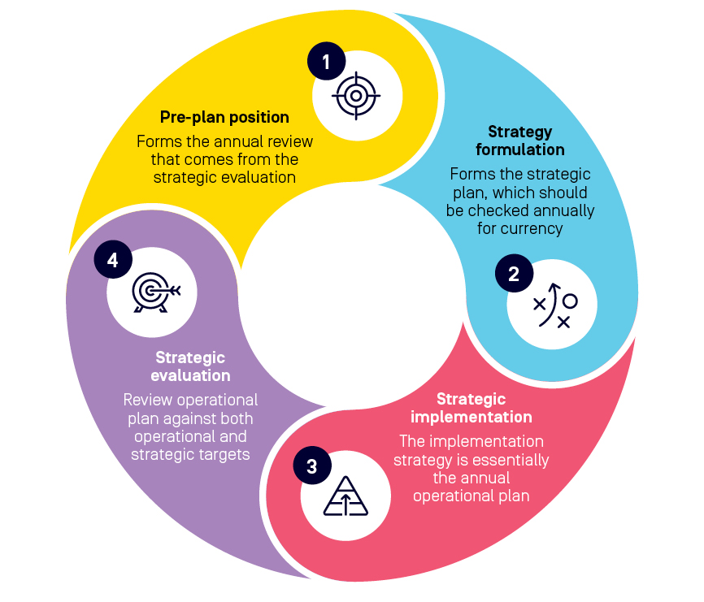

1. Pre-plan Position
Without an accurate assessment of an organisation’s pre-plan position, it is difficult to establish a starting point for the development of a new plan. This section forms the first step in the development of a strategic plan. By conducting a review of the previous year or season and sourcing facts and figures, including various financial, statistical and background information on both internal and external operations, organisations can objectively describe their current status and the starting point for developing a new strategy.

For example, key quantitative measures may include:

- participation numbers (that is, members, coaches, officials and volunteers)
- recruitment and retention rates
- key financial indicators and results

Review of the previous year

By reviewing the previous year’s operational plan and annual report, organisations can identify the extent to which tasks were completed, state the reasons for failing to achieve any of the performance targets and identify the implications of this for future years. In addition, organisations can make an assessment on the status of its priorities including whether they have been met, are ongoing for the coming year, or have changed against internal and/or external influences.

It is important that a review includes a financial summary for the previous year that shows the income and expenditure items and an indication of actual financial performance against projected budgets for the previous 12-month operational planning period. This information is critical to assisting the organisation in its financial planning for the coming year.

SWOT Analysis
Understanding the internal and external influences that impact an organisation is an important step that can be easily ascertained through the use of a SWOT analysis; a framework for assessing an organisation’s internal Strengths and Weaknesses, as well as external Opportunities and Threats in the community and market.
A simple and easy-to-use tool, a SWOT analysis is essential to strategic planning and can assist organisations to:
- identify and isolate threats
- address weaknesses and areas for development
- capitalise on strengths
- draw awareness to new opportunities and initiatives
- react and respond proactively to a changing environment
- focus and direct funding and resources to maximise impact

 | Helpful to achieving objectives | Harmful to achieving objectives
Internal (attributes of the organisation) | Strengths | Weaknesses
External (attributes of the environment) | Opportunities | Threats

2. Strategy Formulation
Having assessed the current pre-planning position, organisations should draw upon this information to review or identify the purpose, vision, values, priorities, objectives and key performance indicators that will form the strategic plan.

Purpose Statement
A purpose statement distils the fundamental reason(s) an organisation exists. It articulates why you matter and why you do what you do.
It is important for organisations to understand their purpose. Together with a defined set of values, a purpose statement will guide the direction, priorities and activities that it commits to over a period of time.
See Purpose Statement guidance sheet for further information and examples.

Vision Statement
A strategic vision describes the route an organisation intends to take to develop and strengthen its business. It lays out the strategic course in preparing for the future.
Well-conceived visions are distinctive and should be specific to an organisation. Avoid generic, feel good statements like ‘we will become a leader and the first choice of participants’, which could apply to any organisation. For the strategic vision to function it must encapsulate an organisation’s directional path and provide the board with a reference point for making strategic decisions.
A good vision statement should be representative of the following characteristics.

Graphic | Paints a picture of the kind of organisation the board and management are trying to create and the position in the community and sporting landscape it wishes to occupy
Directional | Is forward looking and describes the strategic course for the future
Focused | Is specific enough to provide board and management with guidance in making decisions and allocating resources
Flexible | Is not a ‘once and for all statement’. The directional course and priorities of the board and management may need to be adjusted as circumstances change
Feasible | Is within the realm of what the organisation can reasonably expect to achieve
Desirable | Indicates why the direction makes good sense and it is in the long-term interests of the organisation and its stakeholders
Easy to communicate | Can be easily explained and reduced to a simple, memorable slogan

See Vision Statement guidance sheet for further information and examples.

Value Statement
A value statement conveys the values and priorities of an organisation. It encapsulates for members and the local community what is important to your organisation and the culture that guides its behaviours and decision-making.
It should show what an organisation believes in. It is the backbone which can be referred to as context for what to do next and how to act.
See Value Statement guidance sheet for further information and examples.

Key Objectives
Key objectives can be defined as the results an organisation hopes to achieve when attempting to pursue its vision and purpose within the time frame of the plan. It is essential for an organisation to state its long-term objectives as they will indicate the direction of the organisation and assist with future evaluation. Stating the long-term objectives can also enable an organisation to reveal its strategic priorities.
All objectives should have the following attributes:
- Specific – write objectives simply and describe exactly what will be accomplished when each objective is achieved.
- Measurable – the objective needs to be measurable so it can be determined when it has been achieved. If it cannot be measured it might not be manageable.
- Achievable – Expect to achieve the objective and do not set objectives too high or make them unrealistic.
- Related to the vision – The objectives must relate to the vision of your organisation.
- Time bound – Each objective must have an achieve-by date. A deadline is a great motivator for achieving objectives.

Strategic Priorities
Strategic priorities describe the strategies and tasks an organisation will perform in order to achieve its objectives. For example, if a long-term objective is, ‘To increase the number of junior participants in the organisation’, then the strategic priority to help achieve this may be, ‘To implement a modified that enables primary school age children to participate outside of traditional weekend sport hours’.
When writing strategies, an organisation should describe what it aims to accomplish by using verbs to start the strategy, such as: foster, develop, provide, prepare, produce, organise, perform, nurture, support, explore, promote, advance, build, introduce, deliver, adopt, sustain and build.

Key Performance Indicators
Key performance indicators (KPIs) should enable an organisation to identify the criteria it will use to measure its performance against each strategic priority. KPIs will determine the extent to which the strategies have been achieved and are the measures by which evaluation and feedback on performance are based. They should be related to the strategies and could include quality, quantity and time components.
Examples of key performance indicators follow:
- increased levels of funding and services between the sport and key stakeholders
- 5 per cent increase in registered members
- 90 per cent member satisfaction with upgraded web-based communication systems
The One Page Strategic Plan template provides a useful and simple framework by which to capture, refer to and communicate an organisation’s strategic plans on a page

3. Strategy Implementation
Transitioning from planning to implementation can be tricky. The below implementation framework can help organisations manage the process by drawing attention to key areas of the business impacted by changes to the strategic plan and recommended activity for ensuring a smooth transition.

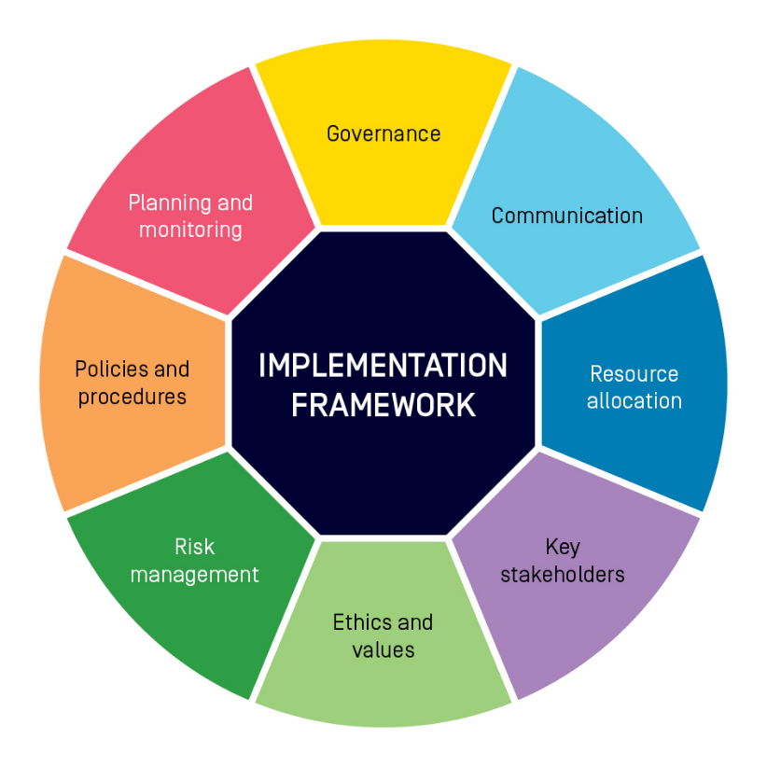

Element | Activity
Governance | Ensure policies and procedures, decision making, and reporting align to the strategic direction of the organisation
Communication | Distribute planning documents to the appropriate key stakeholders
Resource allocation | Realign organisation structures and budgets against the plan where required
Key stakeholders | Ensure key stakeholders, including members, sponsors, associations are made aware of the strategic plan and organisation direction
Ethics and values | Manage conflicts of interest as they arise
Risk management | Establish a risk management plan to help identify, assess and respond to risks involved in implementing the plan
Policies and procedures | Update all policies and procedures
Planning and monitoring | Monitor and evaluate plans regularly (at least annually)

Operational Plan
Separate to the strategic plan, an operational plan is a management tool that details the tasks, personnel, timings and costs associated with each strategic priority.
Operational plans can be broken down into day-to-day, weekly or monthly action items, and are useful in keeping organisations on-track and accountable for each objective within the strategic plan.

Operating Budget
The annual projected operating budget is used to project the annual financial results over a yearly period. This type of budget would be used to assess the financial capacity of an organisation to manage the operations required to achieve its strategic objectives.
It is used to measure the financial impact of both expenditure and income that is expected over the coming 12-month period. Therefore, it is important to take into consideration all legitimate income and worst-case expenditure to ensure unrealistic expectations are not projected. Allowances should be made for extraordinary expenses, which may occur into the future. Once the budget is completed the organisation should also consider ‘what if’ scenarios to gain an estimate of the impact changes to income and expenditure may have.

4. Strategic Evaluation
Commonly the most neglected stage of the planning process is the monitoring, evaluation and review of the strategic plan.
Planning should not stop with when the strategic and operational plan has been adopted by members and the committee. It is an organisation’s most important reference document and should be used constantly throughout the year, providing context for decision-making. It also helps organisations monitor performance and financial status.
Tips for monitoring, evaluating and reviewing plans include:
- Appoint people who will be responsible for monitoring performance against the plan.
- Ensure specific timeframes have been allocated to implement the strategies.
- Develop formal reporting procedures for the designated person or action plan group to comply with or update established reporting processes.
- Check progress regularly against the plan. This should be included as a regular item on management meeting agendas.
- Modify the plan if it is not possible to achieve some of the goals that have been set.
- Establish a planning subcommittee to review the whole plan each year to check whether the organisation has achieved its goals for the year and to add another year to the plan. Organisations should be constantly planning three to four years ahead.
- If changes to the plan are not major, you could treat the previous year’s plan as a draft and circulate it for amendment or extension.

Key questions to ask when undertaking an evaluation process are:
- Have any major changes occurred with the organisation’s internal position?
- Have any major changes occurred with the organisation’s external position?
- Is the organisation progressing well towards achieving its objectives?

