Airport and aviation facilities overlay code

Application
This code applies to development:-

- subject to the airport and aviation facilities identified in the SPP interactive mapping system; and

- identified as requiring assessment against the Airport environs overlay code by the tables of assessment in Part 5 (Tables of assessment).

Purpose and overall outcomes
- The purpose of the Airport environs overlay code is to protect and maintain the operational efficiency and safety of the Bundaberg Airport and aviation facilities and avoid land use conflicts.

- The purpose of the code will be achieved through the following overall outcomes:-

  - the safety of aircraft operating within the airport’s operational airspace is maintained and enhanced;
Note—operational airspace includes the areas and vertical dimensions of an airport’s obstacle limitation surface (OLS).
  - sensitive land uses and other incompatible activities are appropriately located and designed to ensure that these uses and activities do not adversely impact on airport operations;

  - the risk of public safety being compromised by incidents in the take-off and landing phases of aircraft operations is minimised;

  - development protects aviation facilities including navigation, communication and surveillance facilities from incompatible land uses, buildings, structures and works.

Specific benchmarks for assessment

Table 8.2.3.3.1 Benchmarks for assessable development
Performance outcomes | Acceptable outcomes | Compliance / Representations
Obstructions and hazards
PO1  Development does not cause an obstruction or hazard to the safe movement of aircraft through the temporary or permanent intrusion of physical structures into the airport’s operational airspace, particularly take-off and approach flight paths. | AO1  Buildings, structures (both freestanding and attached to buildings, including signs, masts or antennae) and vegetation at its mature height do not intrude into the obstacle limitation surface (OLS) of the airport.  Editor’s note—where proposed development is likely to intrude into the OLS of the airport, it is highly recommended that CASA and Airservices Australia be consulted prior to the lodgement of any development application to determine how compliance with performance outcome PO1 can be achieved. | Provide a brief description how your proposal complies with the relevant Acceptable outcome (if applicable) or a detailed analysis how compliance is achieved with the Performance outcome.
PO2  Development does not cause an obstruction or hazard to the safe movement of aircraft within the airport’s operational airspace through the attracting of wildlife, in particular flying vertebrates such as birds or bats, in significant numbers. | AO2.1  Uses involving the bulk handling or disposal of putrescible waste, such as landfill and waste transfer facilities, are not located within a wildlife hazard buffer zone (i.e. within 13km of an airport’s runway).  OR  Where increasing the intensity or scale of an existing use involving the bulk handling or disposal of putrescible waste within a wildlife hazard buffer zone (i.e. within 13km of an airport’s runway), development includes measures to reduce the potential to attract birds and bats.  AO2.2  Uses involving the following activities are not located within the 3km wildlife hazard buffer zone:-  - aquaculture, except where using a recirculating aquaculture system contained within sheds;  - intensive animal industry;  - animal keeping, where involving a wildlife or bird sanctuary; and  - industrial uses, where involving food processing plants or stock handling or slaughtering.  AO2.3  Where uses or activities listed in AO2.2 (above) are located between the 3km and 8km wildlife hazard buffer zones:-  - potential food and waste sources are covered or otherwise secured so they do not present a food source for domestic or other wildlife; and  - development includes measures to reduce the potential to attract birds and bats.  AO2.4  Where recreation and entertainment facilities involving fair grounds, show grounds, outdoor theatres or outdoor cinemas are located within the 3km wildlife hazard buffer zone, potential food and waste sources are covered or otherwise secured so they are not accessible to wildlife.  AO2.5  Landscaping and drainage works (including artificial waterbodies) for development located within the 3km wildlife hazard buffer zone, are designed and installed to minimise bird and bat attracting potential (such as avoidance of fruiting and/or flowering plant species). | Click and provide your representations.
PO3  Development does not cause an obstruction or hazard to the safe movement of aircraft within the airport’s operational airspace through the installation of external lighting that could distract or interfere with a pilot’s vision, or confuse the visual identification of runway, approach or navigational lighting from the air. | AO3  Outdoor lighting (including street lighting and security lighting) located within a lighting area buffer zone does not involve:-  - lighting that shines, projects or reflects above a horizontal plane;  - coloured, flashing or sodium lighting;  - flare plumes; and  - configurations of lights in straight parallel lines 500m to 1,000m in length. | Click and provide your representations.
PO4  Development does not cause an obstruction or hazard to the safe movement of aircraft within an airport’s operational airspace through the emission of particulates, gases or other materials that may cause air turbulence, reduce visibility or affect aircraft engine performance. | AO4  Development does not release the following emissions into operational airspace:-  - gaseous plumes with a velocity exceeding 4.3m/second;  - smoke, dust, ash or steam; or  - emissions with depleted oxygen content. | Click and provide your representations.
Aircraft noise
PO5  Development and land uses that are sensitive to noise interference or noise nuisance:-  - avoid noise affected areas surrounding the airport; or  - are sited, designed and constructed to mitigate noise nuisance to acceptable levels. | AO5  The following uses, or the creation of additional lots to accommodate these uses, are not located on land subject to the nominated Australian noise exposure forecast (ANEF) contour:-  - permanent forms of residential accommodation within the 20 ANEF contour (or greater);  - visitor or temporary accommodation uses including hotel, short-term accommodation and tourist park within the 25 ANEF contour (or greater);  - community uses including child care centre, community care centre, community use, educational establishment, health care services and place of worship within the 20 ANEF contour (or greater);  - business or entertainment uses including food and drink outlet, function facility, service industry, shop, shopping centre, showroom and tourist attraction within the 25 ANEF contour (or greater);  - industry uses including low impact industry and research and technology industry within the 30 ANEF contour (or greater).  OR  Development located within the ANEF contours mentioned above is designed and constructed to attenuate aircraft noise in accordance with Australian Standard AS 2021: Acoustics—Aircraft noise intrusion—Building siting and construction.  Note—AS2021 considers aircraft noise impacts on indoor spaces only. Noise impacts on outdoor use areas will require separate assessment to determine whether noise levels can be mitigated to be within acceptable limits. | Click and provide your representations.
Public safety areas
PO6  Development within the public safety areas located at the end of airport runways avoids:-  - a significant increase in the number of people living, working or congregating in those areas; and  - the use or storage of hazardous materials. | AO6  Development within a public safety area does not introduce or intensify:-  - residential, business, entertainment, industrial, community or recreation activities; or  - any uses involving the production, manufacture or bulk storage of flammable or hazardous goods or materials. | Click and provide your representations.
Aviation facilities
PO7  Development ensures that temporary or permanent physical structures located within an aviation facility’s building restricted area do not interfere with the safe and continued functioning of the aviation facility. | AO7.1  Buildings, structures, trees, fences or any other physical obstructions (including overhead power and telecommunications cables) located in the building restricted area of the Sloping Hummock VHF facility:-  - do not penetrate into Area A as identified on Figure 8.2.3A (Sloping Hummock VHF facility building restricted area); and  - are wholly contained within Area B as identified on Figure 8.2.3A.  Note—there are no constraints to development located in Area C as identified on Figure 8.2.3A.  Figure 8.2.3A Sloping Hummock VHF facility building restricted area  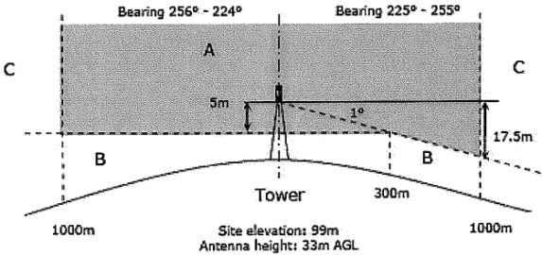  Notes—  1. The Sloping Hummock VHF facility provides air/ground radio communications between air traffic controllers and aircraft in the Bundaberg region and on the ground at Bundaberg Airport. To provide this service the facility requires unobstructed line of sight to the horizon in all directions and to the airport.  2. The building restricted area marked in the diagram is defined with respect to the base of the Airservices Australia VHF antenna mounted on Telstra’s tower. Special consideration is to be given for the area towards Bundaberg Airport (225° to 255°).  AO7.2  Buildings, structures, trees, fences or any other physical obstructions (including overhead power and telecommunications cables) located in the building restricted area of the Bundaberg Airport non-directional beacon (NDB) facility:-  - do not penetrate into ‘Zone A’ as identified on Figure 8.2.3B (Bundaberg Airport NDB facility building restricted area); and  - are wholly contained within ‘Zone B’ as identified on Figure 8.2.3B.  Figure 8.2.3B Bundaberg Airport NDB facility building restricted area  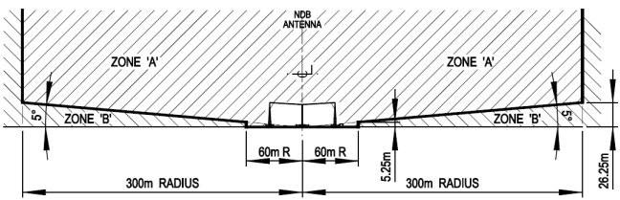  AO7.3  For all other aviation facilities—no acceptable outcome provided. | Click and provide your representations.

Editor’s note—the following elements referred to in this code are identified in the SPP interactive mapping system under the ‘Infrastructure’ theme, subsection ‘Strategic airports and aviation facilities’:- - obstacle limitation surfaces (OLS); - Australian noise exposure forecast (ANEF) contours; - airport public safety areas; - lighting area buffer and wildlife hazard buffer zones; and - aviation facilities and associated building restricted areas.

