Central coastal urban growth area local plan code

Application
This code applies to development:-

- Within the Central coastal urban growth area local plan area as identified on the zoning maps contained in Schedule 2 (Mapping); and

- identified as requiring assessment against the Central coastal urban growth area local plan code by the tables of assessment in Part 5 (Tables of assessment).

Editor’s note—this code seeks to provide a local structure planning framework for the Central coastal urban growth area local plan area. This may include development applications for preliminary approval including a variation request or development applications for reconfiguring a lot.

Purpose and overall outcomes

- The purpose of the Central coastal urban growth area local plan code is to provide for the logical, orderly, efficient and sustainable development of the central coastal urban growth area in a manner that:-

- facilitates the creation of complete and vibrant communities comprising of interconnected residential neighbourhoods and supporting local services, community facilities and open space;

- maintains the discrete identity of individual communities that comprise the central coastal urban growth area; and

- ensures that the pattern of settlement, land use composition and configuration of movement networks and other major infrastructure and open space corridors appropriately reflects local area structure planning undertaken by the Council.

- The purpose of the Central coastal urban growth area local plan code will be achieved through the following overall outcomes:-

  - development for urban purposes occurs only in areas identified for urban development so as to protect the natural environment, preserve areas of open space, minimise impact on economic resources, avoid highly constrained land, maintain separation between discrete communities along the coast and provide for the efficient provision of infrastructure and services;

  - development contributes to a pattern of settlement that maintains and reinforces the local character and identity of discrete communities and neighbourhoods along the central coastal urban growth area by:-

    - preserving two large non-urban areas (inter-urban breaks), between Burnett Heads and Bargara in the north and Coral Cove and Elliott Heads in the south; and
    - retaining and enhancing smaller non-urban areas (intra-urban breaks) that help to distinguish individual places within the urban fabric;

Editor’s note—Figure 7.2.1 (Central coastal urban growth area structure plan concept) identifies the indicative location and extent of inter-urban breaks and intra-urban breaks within the central coastal urban growth area.

  - development maintains and protects significant natural features and landscape values in the central coastal urban growth area, including coastal foreshores, coastal streams and wetland areas, dunes and rocky headlands;

  - development provides for the establishment of a functional and integrated movement network to efficiently and effectively service the central coastal urban growth area;

  - development provides for the establishment of a continuous coastal esplanade to:-

    - enhance accessibility to existing and proposed residential communities along the coast;
    - enhance the public’s appreciation and enjoyment of the coastline; and
    - enhance recreational experiences;

  - development provides for a high level of integration between the open space networks and the pedestrian and bicycle path network;

  - public access to the coast is maintained and, where possible, enhanced by development;

  - development supports the establishment of a network of centres for the broader Central coastal area, comprising:-

    - a district activity centre at Bargara;
    - local activity centres at Burnett Heads, Bargara town centre, Bargara South and Elliott Heads; and
    - a series of well-located neighbourhood centres at other strategic locations throughout the area as required to satisfy community need;

  - development provides for any new activity centres to establish as vibrant, mixed use places with both residential and non-residential activities appropriate to their role and location, and displaying high quality urban design and landscaping;

  - development provides for a specialised activity centre comprising a service station and low impact service industries to establish in Bargara, situated at the corner of Bargara Road and Hughes Road;

  - subject to demonstrated need, a further specialised activity centre/low impact industry area may be established at an appropriate location within the Central coastal urban growth area to predominantly service central coastal area residents and provide local employment opportunities;

  - development in the specialised activity centre/low impact industry areas:-

    - complements, but does not compete with, Bargara’s district activity centre;
    - does not adversely impact on the amenity of any surrounding sensitive land uses; and
    - makes a positive contribution to the visual character of the area, particularly as viewed from major road frontages;

  - where provided, multi-unit residential development sensitively responds to the scale and intensity of existing and planned development and is well-located relative to:-

    - existing and planned activity centres, community facilities and/or transport nodes; and
    - higher order elements of the road network;

  - environmental, open space and rural and landscape protection areas are maintained in the local plan area to provide for the protection and enhancement of rural landscape and scenic amenity values and the maintenance of inter-urban breaks;

  - development provides for an integrated environmental open space network incorporating coastal foreshore areas, watercourses, wetlands and remnant vegetation to provide low impact recreational experiences in addition to habitat protection, rehabilitation, wildlife movement, maintenance of coastal processes, flood conveyance and landscape protection functions;

  - development in Bargara in the vicinity of Seaview Road and Wessells Road protects the rural residential character of expansive homes on spacious grounds in a rural setting;

  - appropriate physical separation, landscape buffering and/or acoustic attenuation is provided within the Central coastal urban growth area to minimise land use conflicts, maintain residential amenity and protect landscape character values, with a particular focus on:-
- maintaining the long-term productive use of agricultural land surrounding the Central coastal urban growth area;
- maintaining the short to medium term productive use of agricultural land within the Central coastal urban growth area; and
- protecting the visual and acoustic amenity of urban areas adjoining major roads and other conflicting land uses within the Central coastal urban growth area;

  - development provides for community uses and activities in appropriate locations to service the needs of the community, including:-

    - the opportunity for a sizable community or institutional facility to be established at the northern end of Hughes Road, potentially accommodating a school, hospital, nursing home, sporting complex or similar activity to service the needs of the community; and
    - the adaptive re-use of Council buildings and facilities near the intersection of Hughes Road and Watsons Road, where these buildings are no longer required for local government purposes.

  - extractive industry sites that are no longer used for extractive industry purposes are protected from unsuitable land uses and fragmentation, and are subject to further investigation to determine suitability for urban development;

  - development of the Burnett Heads Boat Harbour and adjacent foreshore:-

    - provides for an integrated resort development with a range of tourism and related uses including function and entertainment facilities, hotel, retail, residential and marina related businesses; and
    - sensitively responds to and integrates with the Burnett Heads town centre and broader township of Burnett Heads;

  - development within the Central coastal urban growth area does not prejudice or constrain development of the Bundaberg State Development Area, the Port of Bundaberg and Strategic Port Land for port-related and industrial activities and supporting infrastructure, including transport corridors.

Specific benchmarks for assessment

Table 7.2.1.3.1 Benchmarks for assessable development
Performance outcomes | Acceptable outcomes | Compliance / Representations
Pattern of settlement and land use structure
PO1  The pattern of settlement and land use structure:-  - appropriately responds to structure planning undertaken by the Council;  - provides for the growth area to be developed as a series of high quality and discrete residential neighbourhoods offering a diverse mix of generally low to medium density accommodation ranging from dwelling houses on conventional size lots to appropriately located multi-unit residential development in various configurations;  - occurs in a logical sequence that ensures the timely and efficient use of land and provision of infrastructure;  - avoids environmentally significant areas, and areas subject to an unacceptable risk from natural hazards;  - preserves significant natural features and landscape values including coastal foreshores, coastal streams and wetland areas, dunes and rocky headlands;  - incorporates adequate buffering and separation between incompatible land uses; and  - provides physical separation within and between the different communities that comprise the Central coastal urban growth area. | AO1  In partial fulfilment only of Performance outcome PO1:-  Development conforms to a pattern of settlement and land use structure that is generally in accordance with the structure planning elements identified on Figure 7.2.1 (Central coastal urban growth area structure plan concept) and Figure 7.2.1A (Hughes and Seaview Bargara structure plan). | Provide a brief description how your proposal complies with the relevant Acceptable outcome (if applicable) or a detailed analysis how compliance is achieved with the Performance outcome.
Movement network
PO2  Development supports the establishment of an efficient, functional and integrated movement network that:-  - strengthens north-south and east-west road connections, with a particular focus on establishing a north-south coastal link connecting the coastal communities between Burnett Heads and Elliott Heads;  - extends and upgrades Hughes Road to a sub-arterial trunk road linking Bargara and the central coastal southern suburbs and townships;  - improves connectivity between residential neighbourhoods and to existing and proposed activity centres within the Central coastal urban growth area;  - contributes to the efficient and safe functioning of major roads by providing access to development via local roads; and  - promotes the use of pedestrian, cycle and public transport modes. | AO2  In partial fulfilment only of Performance outcome PO2:-  Development provides for the major transport infrastructure networks in a configuration generally in accordance with Figure 7.2.1 (Central coastal urban growth area structure plan concept) and Figure 7.2.1A (Hughes and Seaview Bargara structure plan).  Editor’s Note—temporary road connection/s may be permitted to major roads pending the availability of permanent access via an internal road, at which point the temporary road connection/s will be removed. Example treatments for temporary road connections are shown at Figure 7.2.1B (Conceptual illustration of temporary road connections).  Figure 7.2.1B Conceptual illustration of temporary road connections  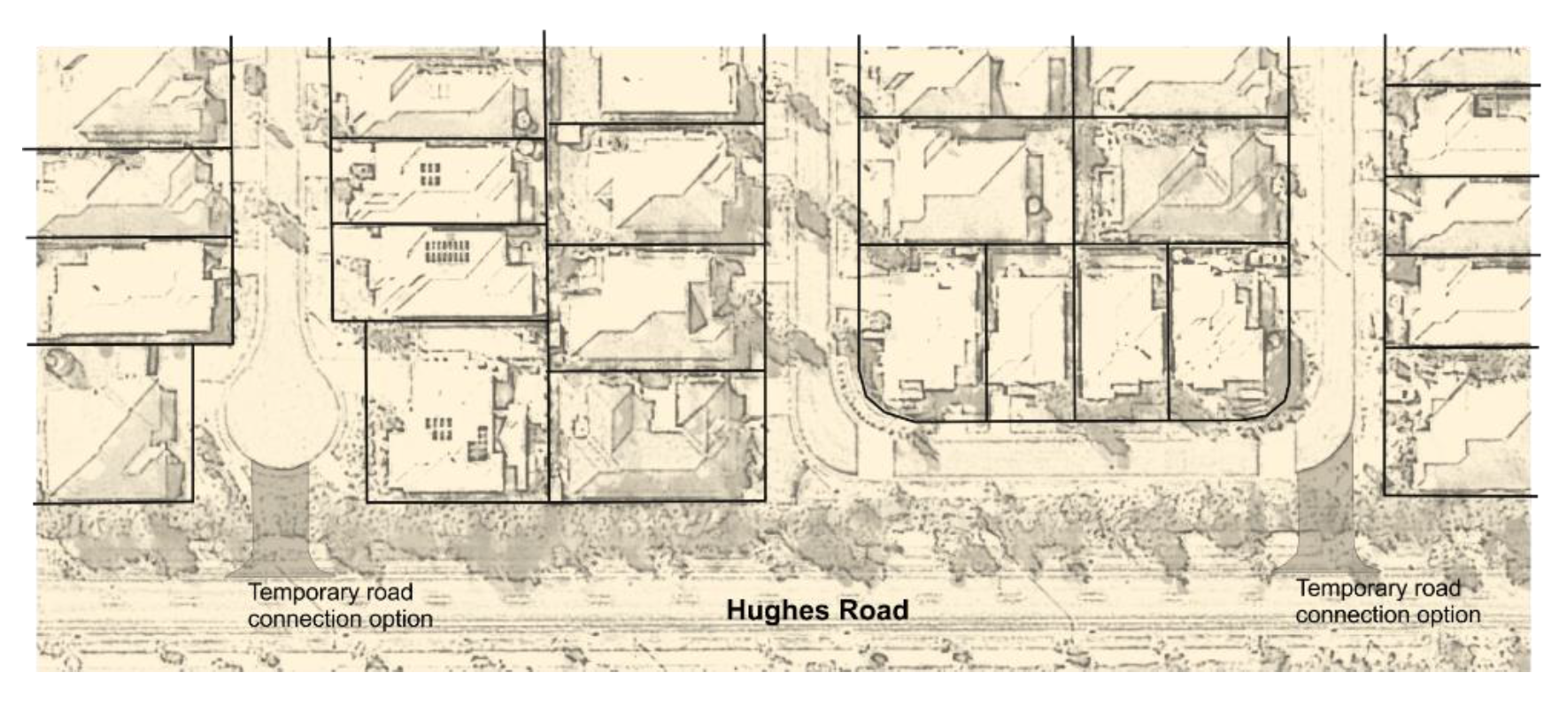 | Click and provide your representations.
PO3  Direct access to major roads is limited to ensure the safe and efficient movement of traffic and safe vehicle access. | AO3  In partial fulfilment only of Performance outcome PO3:-  Where located in the Hughes and Seaview Bargara structure plan area, no direct access is permitted to new residential lots from Bargara Road, Seaview Road and Hughes Road, except for a small number of additional rural residential lots fronting Seaview Road where new shared access is provided to service the new and existing lot/s, avoiding the creation of new access points. | Click and provide your representations.
Continuous coastal esplanade
PO4  Development helps facilitate the provision of a continuous coastal esplanade to provide a scenic drive, pedestrian and bicycle pathway and a walkable waterfront. | AO4  Development provides for the provision of a continuous coastal esplanade, on an alignment generally in accordance with Figure 7.2.1 (Central coastal urban growth area structure plan concept). | Click and provide your representations.
PO5  Development provides for the continuous coastal esplanade to be linked with strong east-west pedestrian and bicycle connections in public open space and road corridors. | AO5  No acceptable outcome provided. | Click and provide your representations.
Activity centres
PO6  New activity centres:-  - are well-located relative to the catchments they are intended to serve and other existing or proposed centres;  - are integrated with community facilities wherever possible;  - have high levels of accessibility to and from the higher order elements of the transport network;  - perform a role and function and have an intensity and scale commensurate with demonstrated need; and  - do not detrimentally impact on existing or approved activity centres. | AO6  In partial fulfilment only of Performance outcome PO6:-  Development provides for a network of activity centres with a function and location generally in accordance with Figure 7.2.1 (Central coastal urban growth area structure plan concept). | Click and provide your representations.
PO7  Development provides for the proposed local activity centres at Bargara South and Elliott Heads to be established and consolidated as pedestrian-based lifestyle centres located at the heart of their respective communities. | AO7  No acceptable outcome provided. | Click and provide your representations.
PO8  Development ensures that any new activity centre:-  - has a configuration and includes a range of uses that help create an active, vibrant centre and focal point for the community;  - is compatible with the scale and intensity of existing or planned development in the neighbourhood; and  - provides for active modes of transport including the provision of sheltered and comfortable spaces for pedestrians with footpaths, walkways and other public spaces adequately sheltered from excessive sunlight and inclement weather. | AO8  No acceptable outcome provided. | Click and provide your representations.
Specialised activity centre/low impact industry area
PO9  Development provides for the establishment of a specialised activity centre including a service station and low impact/service industries near the intersection of Bargara Road and Hughes Road, Bargara. | AO9  Development of a service activity centre/low impact industry area is located generally in accordance with Figure 7.2.1A (Hughes and Seaview Bargara structure plan).  Note—expansion of the specialised activity centre further along the Bargara Road frontage to accommodate other commercial and large format development is not anticipated. | Click and provide your representations.
PO10  Subject to demonstrated need, a further specialised activity centre/low impact industry area may establish within the Central coastal urban growth area, suitably located to service the broader central coastal area. | AO10  No acceptable outcome provided. | Click and provide your representations.
PO11  Development in the specialised activity centre/low impact industry area predominantly accommodates:-  - a service station, small-scale showrooms and other lower-order business activities (e.g. garden centres, hardware and trade supplies and outdoor sales uses) that are not otherwise suited to being located in Bargara’s district activity centre; and  - low impact industry activities and service industries. | AO11  No acceptable outcome provided. | Click and provide your representations.
PO12  Development in the specialised activity centre/low impact industry area:-  - provides an attractive street-front address and makes a positive contribution to the visual character of the area through appropriate built form, urban design and landscaping treatment, especially where located on a major road or entry to a township; and  - does not adversely impact on the amenity of surrounding sensitive land uses, having regard to such matters as traffic, noise, lighting, waste, fumes, odours, hours of operation, privacy, overlooking and public health and safety. | AO12  No acceptable outcome provided. | Click and provide your representations.
Medium density residential development
PO13  Where provided, medium density residential development:-  - has a low-rise built form compatible with the existing and intended scale and character of the surrounding area;  - has high levels of accessibility, increasing the number of people living close (i.e. predominantly within the primary walking catchment) to an existing or planned activity centre, community facility or public open space; and  - is readily accessible to, and capable of being well-serviced by, public transport, bicycle and pedestrian routes. | AO13  Multi-unit residential development:-  - occurs in the Medium density residential areas identified in Figure 7.2.1 (Central Coastal urban growth area structure plan concept) and Figure 7.2.1A (Hughes and Seaview Bargara structure plan);  - provides for a net residential density of 30 to 50 equivalent dwellings per hectare; and  - has a maximum building height of 3 storeys and 11m. | Click and provide your representations.
PO14  Where provided, medium density residential development:-  - provides for a range of multi-unit residential dwelling types and small lot housing;  - is designed to complement the existing and intended character of the area, positively contribute to the streetscape and maintain a high level of residential amenity;  - provides a high quality presentation to major roads with well-articulated built form, high quality landscaping within the set back, and high quality fencing utilising a range of materials and articulation measures. | AO14  No acceptable outcome provided | Click and provide your representations.
Community areas and activities
PO15  Community areas:-  - provide for community or institutional activities, including education, health, sport and recreation and residential care and retirement facilities, that support the needs of the community and are integrated with their surrounding area; and  - where not required for community activities, may be developed for residential and limited non-residential activities consistent with the surrounding area. | AO15.1  Community areas identified in Figure 7.2.1 (Central coastal urban growth area structure plan concept) and Figure 7.2.1A (Hughes and Seaview Bargara structure plan) are developed for community activities.  AO15.2  Development within identified Community areas caters for the needs of the community, and is connected to and forms part of the surrounding neighbourhood, rather than being established as a private enclave.  AO15.3  Where not required for local government purposes, existing Council offices at Bargara, near the intersection of Hughes Road and Watsons Road are adaptively re-used for other community activities. | Click and provide your representations.
Other development
PO16  Other forms of development not anticipated by this local plan may be supported if compliance with the following principles can be demonstrated:-  - development does not interfere with the long-term expectations of the local plan or the logical rollout of urban infrastructure, including water, wastewater, stormwater drainage and roads;  - development does not create unmanageable amenity conflicts, including visual amenity or the release of contaminants from a site; and  - small-scale, non-residential activities that provide a local service may be acceptable in discrete locations. | AO16  No acceptable outcome provided. | Click and provide your representations.
Environmental and open space network
PO17  Development provides for an integrated environmental and open space network that:-  - effectively protects and links major areas of open space and areas of environmental significance;  - retains and protects coastal foreshores and riparian areas for their environmental values and to support a walkable waterfront;  - where practical, contributes to the multimodal pedestrian and cycling network;  - accommodates and conveys major stormwater flows, flood events and drainage affected areas;  - provides physical separation within and between the different communities that comprise the Central coastal urban growth area; and  - contributes to the visual amenity and character of the urban landscape, including at the entrances to coastal townships. | AO17.1  Development provides for open space/ environment protection areas generally in accordance with Figure 7.2.1 (Central coastal urban growth area structure plan concept) and Figure 7.2.1A (Hughes and Seaview Bargara structure plan).  Editor’s note—the extent of the open space/environmental protection areas, including local flood and drainage affected areas, is indicative only and is to be determined at the time of any development application involving the affected land.  AO17.2  The environmental and open space network, including watercourses, flowpaths and local flood and drainage affected areas, is protected from development to ensure the drainage and flood conveyance functions of the network are retained, and where practical:-  - environmental values are retained, enhanced or restored to their natural state;  - provides linear open space that contributes to the open space, pedestrian and cycling networks; and  - where not required as part of the open space or pedestrian and cycle pathway networks, are retained in private ownership.  AO17.3  Open space located within the Bargara Road reserve at the corner of Bargara Road and Seaview Road remains passive in nature and contributes to the landscaped gateway entry statement to Bargara. | Click and provide your representations.
Rural and landscape protection area
PO18  A Rural and landscape protection area is maintained in the Central coastal urban growth area so as to:-  - protect and enhance rural landscape and scenic amenity values;  - retain land for rural production and other non-urban uses that are compatible with the retention of the area’s rural and natural landscape character; and  - facilitate the proper and orderly planning of the Central coastal urban growth area. | AO18.1  Development for urban purposes does not occur in the Rural and landscape protection area identified on Figure 7.2.1 (Central coastal urban growth area structure plan concept).  AO18.2  Development in the Rural and landscape protection area does not compromise the provision of potential future road connections and other infrastructure corridors required to support and service urban development in the central coastal area. | Click and provide your representations.
Further investigation area
PO19  Extractive industry sites that are no longer used for extractive industry purposes:-  - are protected from fragmentation and inappropriate land uses that may compromise their potential longer-term use;  - are not developed for urban purposes until such time as further investigations into the suitability of the land for urban development has been undertaken by Council; and  - contribute towards the retention and creation of intra-urban breaks, and otherwise facilitate the proper and orderly planning of the Central coastal urban growth area. | AO19  No acceptable outcome provided. | Click and provide your representations.
Buffering and separation
PO20  Development incorporates adequate buffering and separation to surrounding rural production areas so as to:-  - maintain the productive use of agricultural land classification (ALC) Class A and Class B land;  - mitigate land use conflicts between rural activities and sensitive land uses within the Central coastal urban growth area; and  - protect the amenity and wellbeing of prospective residents within the broader Central coastal urban growth area. | AO20  Buffers and separation areas to ALC Class A and Class B land and other rural production areas are designed, established and maintained:-  - to provide a minimum 20 metre wide densely landscaped buffer incorporated within the development and held in private ownership, with dwellings or other sensitive receptors set back 30 metres from the road frontage or property boundary; or  - in accordance with an assessment report prepared by an appropriately qualified consultant that demonstrates, to the Council’s satisfaction, compliance with the performance outcome.  Note—Figure 7.2.1 (Central coastal urban growth area structure plan concept) identifies the indicative locations where agricultural land buffers will be required. | Click and provide your representations.
PO21  Development is appropriately staged and designed to ensure that land use conflicts are minimised between the proposed urban residential development and existing farming operations within the Central coastal urban growth area. | AO21  Where development abuts land used for agricultural purposes within the Central coastal urban growth area, temporary buffer treatments and separation areas are:-  - designed, established and maintained to provide a temporary separation area or buffer of 40 metres to the existing agricultural activity consistent with Figure 7.2.1C (Temporary agricultural land buffer concept); and  - designed such that the buffer may be extinguished and developed following the cessation of the adjoining agricultural activity.  Editor’s note—it is envisaged that the 40m wide buffer area would form a stage of the urban development and would be conditioned accordantly by Council through the development approval that the stage that sits over the buffer area cannot be commenced until the adjoining agricultural activity is permanently ceased.  Figure 7.2.1C Temporary agricultural land buffer concept  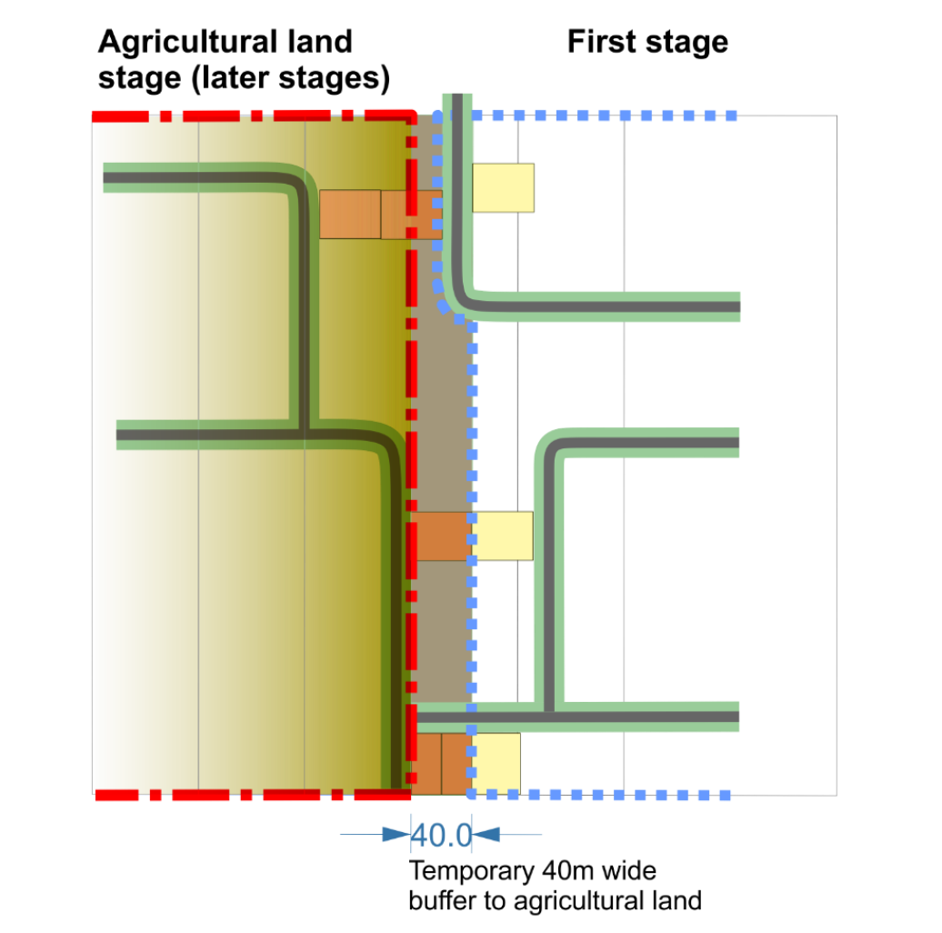 | Click and provide your representations.
PO22  Development provides for acoustic and/or amenity buffers and setbacks to be established and maintained adjacent to major roads and at gateway entrances to townships so as to:-  - protect the amenity and wellbeing of prospective residents and other sensitive receptors within the local plan area;  - protect the function of the road network; and  - enhance roadside amenity and contribute to the visual amenity and character of the coastal townships. | AO22  Development located on a major road incorporates amenity or gateway buffer treatments and setbacks in accordance with the following:-  - acoustic fencing, noise barriers, earth mounding or other treatments are provided where required to ensure road noise does not adversely impact on surrounding sensitive land uses;  - fencing fronting the road, including any required acoustic fencing, is articulated and executed to a high standard commensurate with their prominent position in the landscape;  - a landscaped area (including dense planting with or without earth mounding) of at least 10 metres width is provided between the major road and any fencing provided;  - buildings and structures are set back 6 metres from a major road, except for Bargara Road where buildings must be set back at least 10 metres from the road frontage;  - street tree planting along the adjacent road reserve contributes to a consistent and appealing streetscape. | Click and provide your representations.
Additional requirements for development in the Hughes and Seaview Bargara structure plan area
PO23  Rural residential development is generally located in the vicinity of Wessells Road and consists of low density residential activities where:-  - large residential lots cater for a mix of low density housing choices compatible with the large lot character and amenity of the area, drainage paths and other site constraints;  - additional lots created along Seaview Road comprise of wide street frontages and shared vehicle access; and  - adequate infrastructure is provided, appropriate to the scale of development and applicable site constraints. | AO23  Rural residential development is limited to the large lot residential area identified in Figure 7.2.1A (Hughes and Seaview Bargara structure plan) and achieves the following outcomes:-  - lots are generally not less than 4,000m², except where it can be demonstrated that lots smaller than 4,000m² (not less than 2,000m²) are warranted or appropriate having regard to lot design, site constraints and amenity outcomes;  - each new lot is capable of accommodating a dwelling, associated outbuildings and effluent disposal areas (where on-site wastewater treatment and disposal is accepted), located outside any identified flood hazard area;  - where affected by waterways or overland flow paths, adequate stormwater drainage is provided; and  - where not required as part of the public open space and pathway network, drainage paths remain in private ownership but are included in a drainage easement in favour of Council.  Editor’s note—the extent of the drainage corridors as depicted on Figure 7.2.1A (Hughes and Seaview Bargara structure plan) is indicative only. The exact extent of the drainage corridor is to be determined at the time of any development application. | Click and provide your representations.
PO24  The existing access easement/s off Wessells Road known as Brumby Lane is to be provided as a public road that:-  - provides local vehicle access and pedestrian and cycle connectivity with the broader pathway network; and  - is protected from encroachment by buildings and other development, with buildings set back to provide a streetscape consistent with a conventional low density residential area. | AO24  Brumby Lane is dedicated as a public road consistent with Figure 7.2.1D Brumby Lane concept, and:-  - is designed and constructed as a residential access place and remains a ‘no through road’ for vehicles;  - provides a pedestrian and cycle link between Wessells Road and the low density residential area to the north; and  - new dwellings and appurtenant buildings on the eastern and western side of Brumby Lane (whether access is gained via Brumby Lane or not) are setback in accordance with Figure 7.2.1E Brumby Lane setbacks to allow for future resumptions and widening of Brumby Lane.  Editor’s note—vehicle access from Wessells Road to the low density residential area to the north is not required.  Figure 7.2.1D Brumby Lane concept  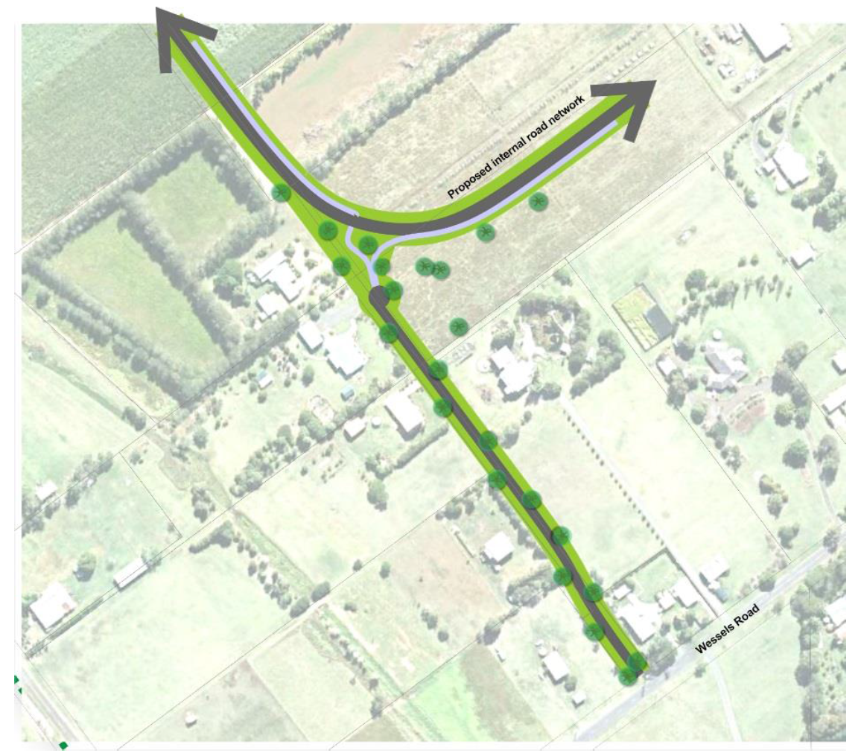  Figure 7.2.1E Brumby Lane setbacks  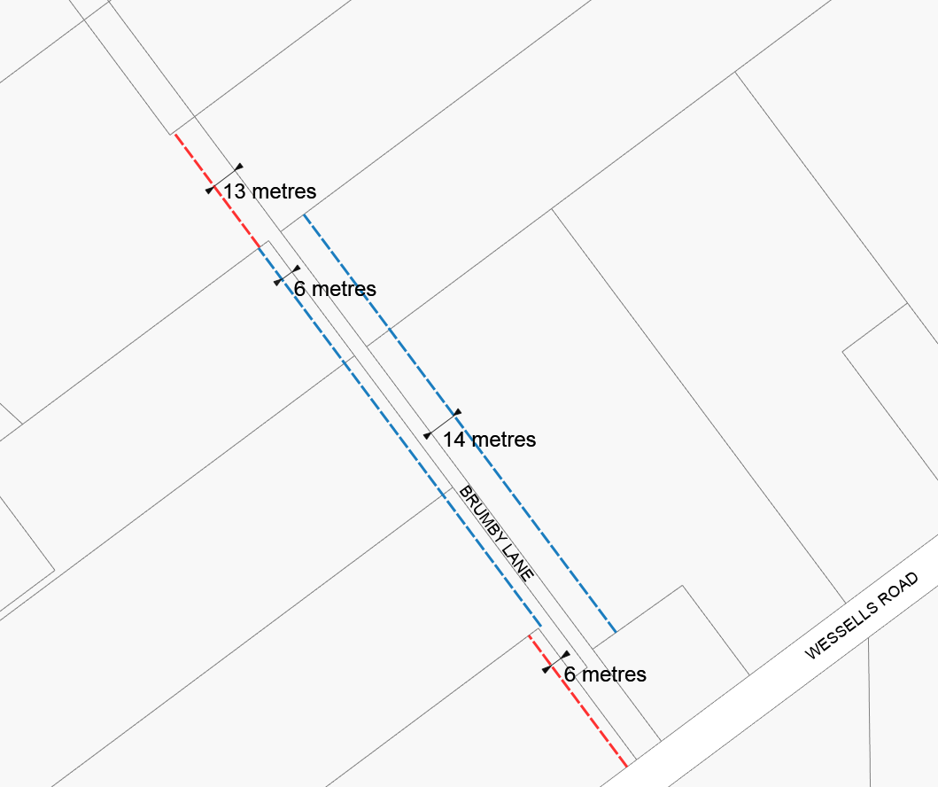 | Click and provide your representations.
Additional requirements for development of the Burnett Heads Boat Harbour development site
PO25  Development within the Burnett Heads Boat Harbour development site:-  - provides the opportunity for a new integrated resort development with a range of related uses including function and entertainment facilities, hotel, retail, tourist attractions, residential, and marina related businesses;  - incorporates a mix of compatible land uses amongst open space areas that are accessible to the broader community;  - provides opportunities for the existing Burnett Heads community through connections and integration with the existing urban form of the locality; and  - manages conflicts between land uses through design elements, buffering and other separation measures.  Editor’s note—land uses that support and complement the boat harbour’s primary use and location are to be integrated so as to minimise potential conflicts. | AO25  No acceptable outcome provided. | Click and provide your representations.
PO26  Development of the Burnett Heads Boat Harbour development site:-  - reflects and promotes a recognisable local character and identity which attracts local, interstate and international visitors;  - incorporates sub-tropical architecture and landscaping;  - is sensitive to the interface and relationship with the Burnett Heads town centre and the broader community; and  - provides continuous public access and high levels of pedestrian amenity along the boat harbour/marina foreshore, connecting with the Burnett Heads town centre and surrounding area;  - provides activity nodes and points of interest along the foreshore; and  - provides active frontages which relate to the waterfront promenade, Harbour Esplanade, and the extensions of Moss and Somerville Streets as pedestrian and view corridors. | AO26  No acceptable outcome provided. | Click and provide your representations.
PO27  Interim uses may be appropriate in the Burnett Heads Boat Harbour development site where the following outcomes are addressed:-  - interim uses are not separately subdivided;  - demonstrates that the use will not prejudice the development potential of the boat harbour; and  - interim land uses will not adversely impact on the amenity of the area, including the established township. | AO27  No acceptable outcome provided. | Click and provide your representations.
Movement network in the vicinity of the Burnett Heads town centre and Boat Harbour development site
PO28  Development at Burnett Heads supports the establishment of an efficient, functional and integrated movement network that:-  - provides improved connectivity to the boat harbour and the Port of Bundaberg by extending Zunker Street (via Lutz Street) to connect with Harbour Esplanade at or near Finucane Street;  - protects the Young Street extension corridor as a potential longer-term town centre by-pass connecting with the Zunker Street extension;  - recognises the importance of Hermans Road in linking the Port of Bundaberg side of Burnett Heads with the Burnett Heads town centre; and  - promotes the continuation of a grid network for local roads, albeit with local streets strategically cul-de-saced to encourage active transport options (i.e. walking or cycling). | AO28  No acceptable outcome provided. | Click and provide your representations.
PO29  Development of the Burnett Heads Boat Harbour development site supports the establishment of an efficient, functional and integrated movement network for active transport (walking and cycling) and passenger transport that:-  - provides a community accessible promenade for the full length of the waterfront;  - facilitates pedestrian access and protects sightlines and views of the boat harbour from Somerville and Moss Streets;  - is easily navigable with a well-connected, logical and legible active transport network that minimises the need for directional signage;  - provides equitable access for all and where practical, separates vehicles from pedestrians and cyclists; and  - caters for buses and service vehicles on site. | AO29  No acceptable outcome provided. | Click and provide your representations.

