Kalkie-Ashfield local development area local plan code

Application

This code applies to development:-

- within the Kalkie-Ashfield local development area local plan area as identified on the zoning maps contained in Schedule 2 (Mapping); and

- identified as requiring assessment against the Kalkie-Ashfield local development area local plan code by the tables of assessment in Part 5 (Tables of assessment).

Editor’s note—this code seeks to provide a local structure planning framework for the Kalkie-Ashfield local development area local plan area. This may include development applications for preliminary approval including a variation request or development applications for reconfiguring a lot.

Purpose and overall outcomes

- The purpose of the Kalkie-Ashfield local development area local plan code is to provide for the logical, orderly, efficient and sustainable development of the Kalkie-Ashfield local development area in a manner that:-

- facilitates the creation of complete and vibrant communities comprising of interconnected residential neighbourhoods and supporting local services, community facilities and open space; and

- ensures that the pattern of settlement, land use composition and configuration of movement networks and other major infrastructure and open space corridors appropriately reflects local area structure planning undertaken by the Council.

- The purpose of the Kalkie-Ashfield local development area local plan code will be achieved through the following overall outcomes:-

- development for urban purposes occurs only in areas identified for urban development so as to protect the natural environment, preserve areas of open space, minimise impact on economic resources, avoid highly constrained land and provide for the efficient provision of infrastructure and services;

- development maintains and protects significant natural features and landscape values in the Kalkie-Ashfield local development area, including the Burnett River foreshore, the ridgeline east of the river in Kalkie, surrounding areas of rural landscape character, the natural path of defined watercourses and areas of environmental significance (including areas of Woongarra Scrub);

- development provides for the establishment of a functional and integrated movement network to efficiently and effectively service the Kalkie-Ashfield local development area;

- a continuous Burnett River esplanade is maintained and improved to:-

    - enhance accessibility to open space and recreational opportunities along the riverside; and
    - enhance the public's appreciation and enjoyment of the Burnett River;

- development provides for a high level of integration between the open space networks and the pedestrian and bicycle path network, including connecting the Kalkie-Ashfield local development area to the Bundaberg CBD via Baldwin Swamp Environmental Park;
- development provides short and long distance views over the Burnett River, farmland and the non-urban setting of Bundaberg for residents and the public by establishing a continuous avenue along the ridgeline between Jealous Road and Sauers Road in Kalkie;

- development supports the establishment of a network of centres for the Kalkie-Ashfield local development area, comprising:-

    - a local activity centre located at or near the midpoint of FE Walker Street/Bundaberg Port Road within the Kalkie-Ashfield local development area; and
    - a series of well-located neighbourhood centres at other strategic locations throughout the area as required to satisfy community need;

- development provides for any new activity centres to establish as vibrant, mixed use places with both residential and non-residential activities appropriate to their role and location, and displaying high quality urban design and landscaping;

- development in the local activity centre:-

    - does not adversely impact on the amenity of any surrounding sensitive land uses;
    - makes a positive contribution to the visual character of the area, particularly as viewed from major road frontages; and
    - may provide for a full-line supermarket where forming part of the local activity centre; and
    - does not contain any other uses that would be more appropriately located in the Bundaberg principal activity centre;

- where provided, multi-unit residential development sensitively responds to the scale and intensity of existing and planned development and is well-located relative to:-

    - existing and planned activity centres, community facilities and/or transport nodes; and
    - higher order elements of the road network;

- a Rural and landscape protection area is maintained along the Burnett River flats, extending from Jealous Road to Kirbys Road to provide for the protection and enhancement of rural landscape, primary production and scenic amenity values and, subject to appropriate address of flooding constraints, the longer term potential of the area adjacent to the Burnett River to accommodate higher order sport and recreation facilities for the Bundaberg Region with a riverfront setting;

- development provides for an integrated environmental open space network incorporating riverine foreshore areas, watercourses, wetlands and remnant vegetation to provide low impact recreational experiences in addition to habitat protection, rehabilitation, wildlife movement, maintenance of riverine and coastal processes, flood conveyance and landscape protection functions;

- rural residential development is limited to a small area in the northern portion of Kalkie to ensure that predominantly urban residential development within the Kalkie-Ashfield local development area is of an appropriate density to benefit from its proximity to Rubyanna Wastewater Treatment Plant, able to conveniently connect to urban services;

- the open space network in the Kalkie-Ashfield local development area connects with and complements the existing active and passive open space system extending along Bundaberg Creek and Baldwin Swamp Environmental Park into Bundaberg East and Bundaberg South;

- development maintains and enhances opportunities for an improved linear open space and pedestrian and bicycle path network extending along the Burnett River providing connectivity between the Kalkie-Ashfield local development area and the Bundaberg CBD via East Bundaberg;

- subject to ensuring the safe and efficient operation of rural infrastructure, development aligns components of the road, open space and pedestrian and cycle path networks with the irrigation channel network and cane rail network through Ashfield, to add visual interest to neighbourhoods and establish a cultural connection between urban development and the agricultural heritage of the area;

- the Bargara Road/Gahans Road/Kingsford Street/Jealous Road intersection is redesigned to improve access and traffic circulation to support the development of new neighbourhoods in Kalkie;

- appropriate physical separation, landscape buffering and/or acoustic attenuation is provided within the local plan area to minimise land use conflicts, maintain residential amenity and protect landscape character values, with a particular focus on:-

    - maintaining the long-term productive use of agricultural land surrounding the Kalkie-Ashfield local development area;
    - maintaining the short to medium term productive use of agricultural land within the Kalkie-Ashfield local development area;
    - separation and buffering of sensitive land uses to industrial activity in Bundaberg East to the south of Jealous Road and in the vicinity of Alexandra Street; and
    - the interface between urban development, major roads and the sugar cane rail network.

Specific benchmarks for assessment

Table 7.2.2.3.1 Benchmarks for assessable development
Performance outcomes | Acceptable outcomes | Compliance / Representations
Pattern of settlement and land use structure
PO1  The pattern of settlement and land use structure:-  - appropriately responds to structure planning undertaken by the Council;  - provides for the growth area to be developed as a series of high quality, interconnected residential neighbourhoods offering a diverse mix of generally low to medium density accommodation ranging from dwelling houses on conventional size lots to appropriately located multi-unit residential development in various configurations;  - occurs in a logical sequence that ensures the timely and efficient use of land and provision of infrastructure;  - avoids environmentally significant areas, and areas subject to an unacceptable risk from natural hazards;  - preserves significant natural features and landscape values including the Burnett River foreshore, the ridgeline east of the river in Kalkie, surrounding areas of rural landscape character, the natural path of defined watercourses and areas of environmental significance (including Woongarra Scrub);  - incorporates adequate buffering and separation between incompatible land uses; and  - provides connections to and continuity with the established Bundaberg settlement pattern through integration between new and existing components of the movement network and the open space network. | AO1  In partial fulfilment only of Performance outcome PO1:-  Development conforms to a pattern of settlement and land use structure that is generally in accordance with the structure planning elements identified on Figure 7.2.2 (Kalkie-Ashfield local development area structure plan concept). | Provide a brief description how your proposal complies with the relevant Acceptable outcome (if applicable) or a detailed analysis how compliance is achieved with the Performance outcome.
Movement network
PO2  Development supports the establishment of an efficient, functional and integrated movement network that:-  - strengthens road and other connections internally within the Kalkie-Ashfield local development area and externally to the established Bundaberg settlement pattern;  - improves north-south connectivity between existing and new residential neighbourhoods to the proposed local activity centre for the Kalkie-Ashfield local development area on FE Walker Street/Bundaberg Port Road;  - strengthens east-west connectivity by providing an integrated movement network that links the Kalkie-Ashfield local development area to the Burnett River, the Bundaberg CBD and surrounding residential neighbourhoods;  - promotes the use of pedestrian, cycle and public transport modes; and  - provides for pedestrian and bicycle path connections between the Kalkie-Ashfield local development area and the Bundaberg CBD via a linear network of open space including Baldwin Swamp Environmental Park. | AO2  In partial fulfilment only of Performance outcome PO2:-  Development provides for the major transport infrastructure networks in a configuration generally in accordance with Figure 7.2.2 (Kalkie-Ashfield local development area structure plan concept). | Click and provide your representations.
Esplanades and avenues
PO3  A continuous esplanade is maintained along the Burnett River bank to provide a scenic drive, pedestrian and bicycle pathway and a walkable waterfront. | AO3  A continuous Burnett River esplanade is maintained generally in accordance with Figure 7.2.2 (Kalkie-Ashfield local development area structure plan concept). | Click and provide your representations.
PO4  Development provides a continuous avenue along the north-south ridgeline in Kalkie between Jealous Road and Sauers Road to:-  - provide a scenic drive and pedestrian and bicycle pathway; and  - secure and retain important views over the Burnett River, farmland and the non-urban setting of Bundaberg for residential and scenic amenity. | AO4  A continuous avenue is provided along the Kalkie ridgeline generally in accordance with Figure 7.2.2 (Kalkie-Ashfield local development area structure plan concept). | Click and provide your representations.
PO5  Development provides for the Kalkie ridgeline scenic avenue to be linked with strong east-west pedestrian and bicycle connections in public open space and road corridors. | AO5  No acceptable outcome provided. | Click and provide your representations.
Activity centres
PO6  New activity centres:-  - are well-located relative to the catchments they are intended to serve and other existing or proposed centres;  - are integrated with community facilities and the open space network wherever possible;  - have high levels of accessibility to and from the higher order elements of the transport network;  - perform a role and function and have an intensity and scale commensurate with demonstrated need; and  - do not detrimentally impact on existing or approved activity centres. | AO6  In partial fulfilment only of Performance outcome PO6:-  Development provides for a network of activity centres with a function and location generally in accordance with Figure 7.2.2 (Kalkie-Ashfield local development area structure plan concept). | Click and provide your representations.
PO7  Development ensures that any new activity centre:-  - has a configuration and includes a range of uses that help create an active, vibrant centre and focal point for the community;  - is compatible with the scale and intensity of existing or planned development in the neighbourhood; and  - provides for active modes of transport including the provision of sheltered and comfortable spaces for pedestrians with footpaths, walkways and other public spaces adequately sheltered from excessive sunlight and inclement weather. | AO7  No acceptable outcome provided. | Click and provide your representations.
PO8  A local activity centre is established centrally within the Kalkie-Ashfield local development area at or near the midpoint of FE Walker Street/Bundaberg Port Road. | AO8  In partial fulfilment only of Performance outcome PO8:-  The local activity centre is located on the southern side of FE Walker Street/Bundaberg Port Road at the midpoint of this road within the Kalkie-Ashfield local development area generally in accordance with Figure 7.2.2. (Kalkie-Ashfield local development area structure plan concept). | Click and provide your representations.
PO9  Neighbourhood activity centres provide small scale convenience ‘top up’ shopping and local food and drink outlet services for an adjacent residential neighbourhood. | AO9  No acceptable outcome provided. | Click and provide your representations.
PO10  Local and neighbourhood activity centres may include permanent and short-term residential accommodation, provided that active (non-residential) frontages are maintained at street level. | AO10  Residential uses are located above street level or to the rear of buildings with active (non-residential) street frontages. | Click and provide your representations.
PO11  Development in the local activity centre:-  - provides for local weekly shopping and service needs including a mix of traditional retail (shops), commercial, cafes/dining, entertainment and community activities; and  - may include a full-line supermarket. | AO11  No acceptable outcome provided. | Click and provide your representations.
PO12  Development in the local activity centre:-  - provides an attractive streetfront address to major roads and makes a positive contribution to the visual character of the area through appropriate built form, urban design and landscaping treatment; and  - does not adversely impact on the amenity of surrounding sensitive land uses, having regard to such matters as traffic, noise, lighting, waste, fumes, odours, hours of operation, privacy, overlooking, micro-climatic impacts (e.g. overshadowing and blocking of breezes), and public health and safety. | AO12  No acceptable outcome provided. | Click and provide your representations.
Medium density residential development
PO13  Where provided, medium density residential development:-  - has high levels of accessibility (i.e. predominantly within the primary walking catchment) to an existing or planned activity centre or community facility; or  - is located to take advantage of views to the Burnett River or other features that provide a particular amenity supporting higher density; and  - is readily accessible to, and capable of being well-serviced by, public transport, bicycle and pedestrian routes; and  - achieves a net residential density of 30 to 50 equivalent dwellings per hectare. | AO13  No acceptable outcome provided. | Click and provide your representations.
Rural residential development
PO14  Rural residential development is limited to areas identified within Figure 7.2.2 (Kalkie-Ashfield local development area structure plan concept) and:-  - sensitively responds to the prevailing local character, amenity values and other site constraints; and  - provides a suitable buffer to rural land in order to mitigate conflicts between sensitive land uses and existing and potential agricultural activity. | AO14  No acceptable outcome provided. | Click and provide your representations.
Environmental and open space network
PO15  Development provides for an integrated environmental and open space network that:-  - effectively protects and links major areas of open space and areas of environmental significance, including Woongarra Scrub;  - retains and protects the Burnett River foreshore and riparian areas for their environmental values and to support a walkable waterfront; and  - accommodates and conveys major stormwater flows and flood events. | AO15  In partial fulfilment only of Performance outcome PO15:-  Development provides for open space/environment protection areas generally in accordance with Figure 7.2.2 (Kalkie-Ashfield local development area structure plan concept). | Click and provide your representations.
PO16  Land adjacent to the Burnett River in Kalkie is kept available for the potential long term development of higher order sport and recreation facilities meeting the needs of the Bundaberg Region, subject to appropriate address of flooding constraints. | AO16  No acceptable outcome provided. | Click and provide your representations.
Rural and landscape protection area
PO17  A Rural and landscape protection area is maintained in the Kalkie-Ashfield local development area so as to:-  - protect and enhance rural landscape and scenic amenity values;  - retain land for rural production and other non-urban uses that are compatible with the retention of the area’s rural and natural landscape character; and  - facilitate the proper and orderly planning of the Kalkie-Ashfield local development area. | AO17.1  Development for urban purposes does not occur in the Rural and landscape protection area identified on Figure 7.2.2 (Kalkie-Ashfield local development area structure plan concept).  AO17.2  Development in the Rural and landscape protection area does not compromise the provision of potential future road connections and other infrastructure corridors required to support and service urban development in the Kalkie-Ashfield local development area. | Click and provide your representations.
Buffering and separation
PO18  Development incorporates adequate buffering and separation to surrounding rural production areas so as to:-  - maintain the productive use of agricultural land classification (ALC) Class A and Class B land;  - mitigate land use conflicts between rural activities and sensitive land uses within the Kalkie-Ashfield local development area; and  - protect the amenity and wellbeing of prospective residents within the Kalkie-Ashfield local development area. | AO18  Buffers and separation areas to ALC Class A and Class B land and other rural production areas are designed, established and maintained:-  - to provide a minimum 20 metre wide densely landscaped buffer incorporated within the development and held in private ownership, with dwellings or other sensitive receptors set back 30 metres from the road frontage or property boundary; or  - in accordance with an assessment report prepared by an appropriately qualified consultant that demonstrates, to the Council’s satisfaction, compliance with the performance outcome.  Note—Figure 7.2.2 (Kalkie-Ashfield local development area structure plan concept) identifies the indicative locations where agricultural land buffers will be required. | Click and provide your representations.
PO19  Development is appropriately staged and designed to ensure that land use conflicts are minimised between proposed urban residential development and existing farming operations within the Kalkie-Ashfield local development area. | AO19  Where development abuts land used for agricultural purposes within the Kalkie-Ashfield local development area, temporary buffer treatments and separation areas are:-  - designed, established and maintained to provide a temporary separation area or buffer of 40 metres to the existing agricultural activity consistent with Figure 7.2.2A (Temporary agricultural land buffer concept); and  - designed such that the buffer may be extinguished and developed following the cessation of the adjoining agricultural activity.  Editor’s note—it is envisaged that the 40m wide buffer area would form a stage of the urban development and would be conditioned accordantly by Council through the development approval that the stage that sits over the buffer area cannot be commenced until the adjoining agricultural activity is permanently ceased.  Figure 7.2.2A Temporary agricultural land buffer concept  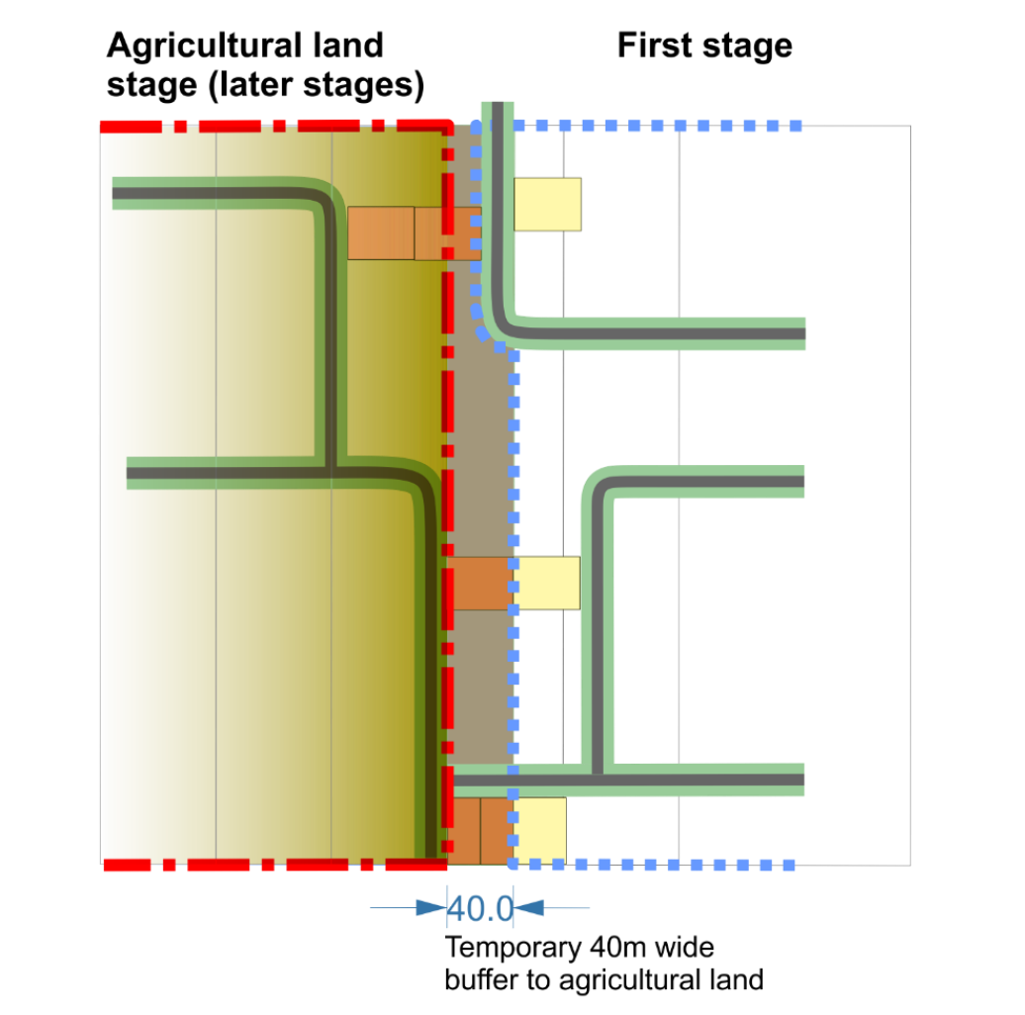 | Click and provide your representations.
PO20  Development provides for an acoustic and amenity buffer to be established and maintained adjacent to the major roads and the sugar cane rail network so as to:-  - protect the amenity and wellbeing of prospective residents and other sensitive receptors within the local plan area;  - protect the function of the road network and sugar cane rail network; and  - enhance roadside amenity and contribute to the visual amenity of the development area.  Note—Figure 7.2.2 (Kalkie-Ashfield local development area structure plan concept) identifies the indicative locations where acoustic and amenity buffers will be required along major roads and the sugar cane rail network.  The acoustic and amenity buffer area may be provided in a variety of forms including but not limited to:  - private freehold land forming a component of a residential lot outside of a designated building envelope;  - common property in a community titles scheme;  - private landscape and recreation space;  - existing or new road reserve; or  - public open space reserve. | AO20  No acceptable outcome provided. | Click and provide your representations.
PO21  Acoustic attenuation or property boundary fencing does not visually dominate the interface to major road corridors. | AO21  An acoustic and amenity buffer comprising a landscaped area (including dense planting with or without earth mounding) of at least 10m width is provided between the boundary of major roads and any noise barrier or other fencing provided for or by adjoining development. | Click and provide your representations.
PO22  Residential development and other sensitive land uses are separated from industrial activity in Bundaberg East to the south of Jealous Road and in the vicinity of Alexandra Street by a buffer distance and treatment sufficient to ensure a satisfactory standard of amenity, free from unpleasant odours and other impacts arising from noise, lighting or other aspects of the plant’s operations. | AO22  No acceptable outcome provided. | Click and provide your representations.
Infrastructure and services
PO23  Where available, development is connected to urban services, with the exception of large lot residential development where commensurate with a rural residential location. | AO23  No acceptable outcome provided. | Click and provide your representations.
PO24  Development does not adversely impact on the continued operation, viability and maintenance of existing infrastructure (including the Bundaberg Port Gas Pipeline) or compromise the future provision of planned infrastructure. | AO24  No acceptable outcome provided. | Click and provide your representations.
Rural infrastructure
PO25  The safety and efficiency of existing rural infrastructure supporting primary production, including cane rail lines and irrigation channels, is maintained. | AO25  No acceptable outcome provided. | Click and provide your representations.
PO26  Where the safe and efficient operation of the rural infrastructure can be demonstrated, elements of the cane rail network and the irrigation channel network are incorporated into road reserves, open space and pedestrian and cycle paths. | AO26  No acceptable outcome provided. | Click and provide your representations.

